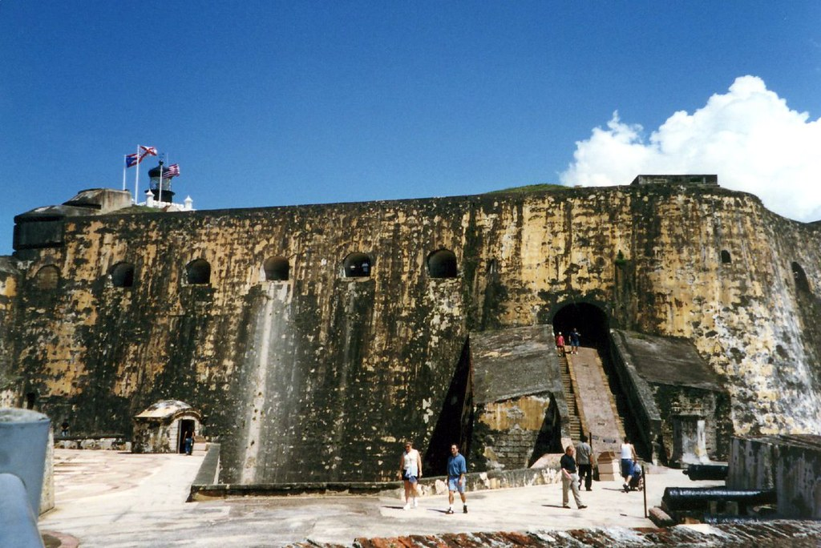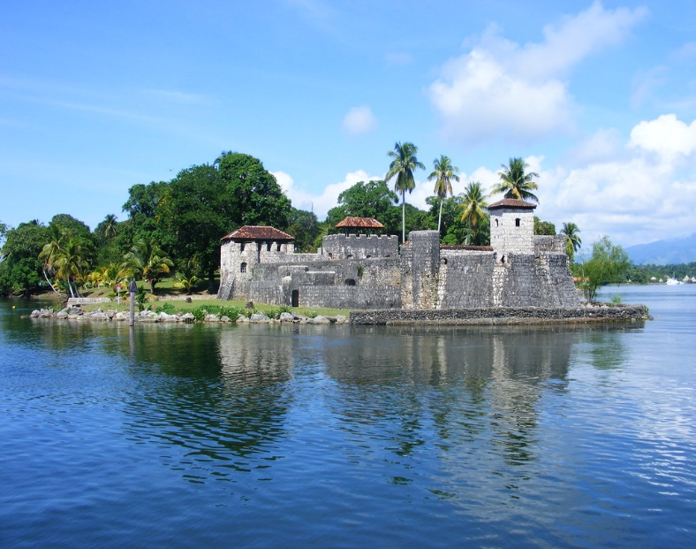

# Castillo San Felipe del Morro

**Castillo San Felipe del Morro** ([English](https://en.wikipedia.org/wiki/English_language): Promontory Castle of Saint Philip), most commonly known as ***El Morro*** *(*The Promontory*)*, is a large [fortress](https://en.wikipedia.org/wiki/Medieval_fortification) and [citadel](https://en.wikipedia.org/wiki/Citadel) in the historic district of [Old San Juan](https://en.wikipedia.org/wiki/Old_San_Juan) in [Puerto Rico](https://en.wikipedia.org/wiki/Puerto_Rico). Commissioned by [King Charles I of Spain](https://en.wikipedia.org/wiki/Charles_V,_Holy_Roman_Emperor) in 1539, it was first built as a [fortified tower](https://en.wikipedia.org/wiki/Fortified_tower) in honor of [King Philip II](https://en.wikipedia.org/wiki/Philip_II_of_Spain), who oversaw its expansion into a [hornwork fort](https://en.wikipedia.org/wiki/Hornwork" \o "Hornwork) by 1595. Over the next 200 years, especially in the reign of [King Charles III](https://en.wikipedia.org/wiki/Charles_III_of_Spain), *El Morro* continued to be developed to reach its current form in 1787. Rising 140 ft from the [Atlantic](https://en.wikipedia.org/wiki/Atlantic_Ocean) shoreline with 18 to 25 ft thick walls, the six-leveled edifice stands on a steep, rocky [headland](https://en.wikipedia.org/wiki/Headland) [promontory](https://en.wikipedia.org/wiki/Promontory) on [San Juan Islet](https://en.wikipedia.org/wiki/San_Juan_Islet) guarding the entry to [San Juan Bay](https://en.wikipedia.org/wiki/San_Juan_Bay), the harbor of [Old San Juan](https://en.wikipedia.org/wiki/Old_San_Juan).[[3]](https://en.wikipedia.org/wiki/Castillo_San_Felipe_del_Morro#cite_note-3) *El Morro*, alongside [La Fortaleza](https://en.wikipedia.org/wiki/La_Fortaleza), [San Cristóbal](https://en.wikipedia.org/wiki/Castillo_San_Crist%C3%B3bal_(San_Juan)), [El Cañuelo](https://en.wikipedia.org/wiki/Fort%C3%ADn_San_Juan_de_la_Cruz), and other forts part of the [Walls of Old San Juan](https://en.wikipedia.org/wiki/Walls_of_Old_San_Juan), protected [strategically and militarily](https://en.wikipedia.org/wiki/Geography_of_Puerto_Rico#Strategic_geography) important [Puerto Rico](https://en.wikipedia.org/wiki/Puerto_Rico), or *La Llave de las Indias* (The Key to the [Indies](https://en.wikipedia.org/wiki/Council_of_the_Indies)),[[4]](https://en.wikipedia.org/wiki/Castillo_San_Felipe_del_Morro#cite_note-4) from invasion by competing [world powers](https://en.wikipedia.org/wiki/List_of_modern_great_powers#Early_modern_powers) during the [Age of Sail](https://en.wikipedia.org/wiki/Age_of_Sail).[[5]](https://en.wikipedia.org/wiki/Castillo_San_Felipe_del_Morro#cite_note-nps.gov-5) It was designated a [World Heritage Site](https://en.wikipedia.org/wiki/World_Heritage_Site) by [UNESCO](https://en.wikipedia.org/wiki/UNESCO) in 1983.

## **History**

Upon the advice of [Gonzalo Fernández de Oviedo y Valdés](https://en.wikipedia.org/wiki/Gonzalo_Fern%C3%A1ndez_de_Oviedo_y_Vald%C3%A9s), a battery was constructed on the rocky promontory called "the Morro", when the location of [La Fortaleza](https://en.wikipedia.org/wiki/La_Fortaleza) was deemed unsuitable. This battery consisted of a tower with 4 [embrasures](https://en.wikipedia.org/wiki/Embrasure), and a Water Battery at the foot of the slope for 3 guns. By 1555, Morro had 8 bronze cannons, as a defense against French [privateers](https://en.wikipedia.org/wiki/Privateer).[[9]](https://en.wikipedia.org/wiki/Castillo_San_Felipe_del_Morro#cite_note-RA-9)[[8]](https://en.wikipedia.org/wiki/Castillo_San_Felipe_del_Morro#cite_note-NPS-8)

During the Spanish government of the island, El Morro, also known as Castillo de San Felipe, survived several attacks from foreign powers on various occasions.

In 1593 Portuguese soldiers, sent from Lisbon by order of Phillip II, composed the first garrison of the San Felipe del Morro fortress in Puerto Rico. Some brought their wives, while others married Puerto Rican women, and today there are many Puerto Rican families with Portuguese last names.

In 1595, Englishman Sir [Francis Drake](https://en.wikipedia.org/wiki/Francis_Drake) unsuccessfully attacked [San Juan](https://en.wikipedia.org/wiki/San_Juan,_Puerto_Rico) with his fleet in the [Battle of San Juan (1595)](https://en.wikipedia.org/wiki/Battle_of_San_Juan_(1595)).

In 1598, the English attacked again, led by [George Clifford](https://en.wikipedia.org/wiki/George_Clifford,_3rd_Earl_of_Cumberland), 3rd Earl of Cumberland. Clifford succeeded because he attacked San Juan over land instead of trying to enter through the San Juan Bay. However, an epidemic of [dysentery](https://en.wikipedia.org/wiki/Dysentery) forced him to flee the island after the [Battle of San Juan (1598)](https://en.wikipedia.org/wiki/Battle_of_San_Juan_(1598)).

In 1625, the [Dutch](https://en.wikipedia.org/wiki/Netherlands), led by [Boudewijn Hendricksz](https://en.wikipedia.org/wiki/Boudewijn_Hendricksz" \o "Boudewijn Hendricksz), also attacked the island emulating George Clifford's overland invasion. To the amazement of the citizens, the invaders were able to pass in front of the castle's defenders and into the harbor, out of reach of the city's cannons. El Morro managed to resist the siege and eventually made the Dutch retire, although the attackers were able to sack and burn the city before leaving the [Battle of San Juan (1625)](https://en.wikipedia.org/wiki/Battle_of_San_Juan_(1625)).

In 1797, British General Ralph Abercromby and Admiral Henry Harvey, with a force of 7,000–13,000 men, invaded the island of Puerto Rico. Captain General Don Ramón de Castro and his forces repelled the attack. Abercromby and Harvey were defeated in the [Battle of San Juan (1797)](https://en.wikipedia.org/wiki/Battle_of_San_Juan_(1797)).

El Morro's last active fight occurred during a naval bombardment by the [United States Navy](https://en.wikipedia.org/wiki/United_States_Navy) during the 1898 [Spanish–American War](https://en.wikipedia.org/wiki/Spanish%E2%80%93American_War), ending the age of naval warfare in the Caribbean, at least in the classical sense. During the Spanish–American War, the castle was attacked at least three times by American naval forces, the largest being the [Bombardment of San Juan](https://en.wikipedia.org/wiki/Bombardment_of_San_Juan) on May 12, 1898. The war ended with the signing of the [Treaty of Paris](https://en.wikipedia.org/wiki/Treaty_of_Paris_(1898)), in which Spain ceded ownership of the islands of [Puerto Rico](https://en.wikipedia.org/wiki/Puerto_Rico), [Cuba](https://en.wikipedia.org/wiki/Cuba), Guam, and the Philippines to the United States.